Minutes of the Meeting of Glapwell Parish Council, held on Thursday 26th October 2023 in the Glapwell Centre, The Green, Glapwell.

**Members present:**

Cllrs C Fleetwood, J Ritchie, P Clough, R Hibbert, I Grainger-Grimes, D Harvey

**Apologies:**

None

**In attendance:**

J Marriott (Responsible Finance Officer)

Dr J Clarke (Parish Clerk)

**Public Participation**

1 member of the public attended.

**BUSINESS**

**Public speaking**

The member of the public asked if the bus stop near the Colliery Memorial could be replaced. The bus stop adjacent to The Young Vanish was dirty. A bollard on the A617 is missing. The Clerk is to investigate these issues.

**01/10/23 Apologies for absence**

None had been submitted

**02/10/23 To receive declarations of interests**

Cllrs Clough and Fleetwood declared a personal interest as Trustees of the Glapwell Guardians.

All councillors present declared a personal interest in the Glapwell Community Sports Association.

Cllr Ritchie declared a personal interest in Glapwell Cricket Club.

**03/10/23 Minutes**

**RESOLVED That:** these minutes were approved as an accurate record of the meeting held on Thursday 28th September 2023.

**04/10/23 Exclusion of Public**

None

**05/10/23 Reports**

1. **Parish Clerk’s report**

The Clerk’s report concentrated on the recent fire fighting that the staff had to handle with regards to the leaking roof in the community centre end and the broken boiler in the sports hall end.

1. **District Councilor’s report**

Cllr Ritchie reported on the recent flooding at Pleasley Vale. Bolsover District Council had applied for Bellwin monies.

There were currently 17,000 on the housing waiting list.

£583, 000 of pre-Devo monies was being used to do a housing stock survey,

1. **County Councilor’s report**

Cllr Barron was not present.

1. **Police Report**

No report had been submitted.

1. **Glapwell Centre Manager’s report**

The Manager’s report showed an uptick in activities at the Community Centre and increased usage of the MUGA and Hall Corner.

**06/10/23 Planning**

No applications.

**07/10/23 Items for Consideration and Decision**

- **Renovation of the community centre (standing item).** The roof was leaking badly and, without repair, the centre would have to be closed for activities. The boiler in the sports hall end was also not working. Bolsover District Council had offered the parish a loan.

- **The football ground and MUGA (standing item).** A complaint was made about a sign being ripped down at Hall Corner as well as prohibited consumption of alcohol. The parish staff would investigate this.

- **Sports hall boiler.**  It was agreed that the boiler in the sports hall needed replacing and this would be procured via Bolsover District Council.

**RESOLVED That:** The Parish would apply to Bolsover District Council for a £50,000 loan to fix the roof and boiler.

**08/10/23 Items for Information Only**

1. **Correspondence**

None received

1. **Items for Information**

None received

**09/10/23 Finance**

1. Payments for authorisation

Council received the list of payments for authorisation for approval.

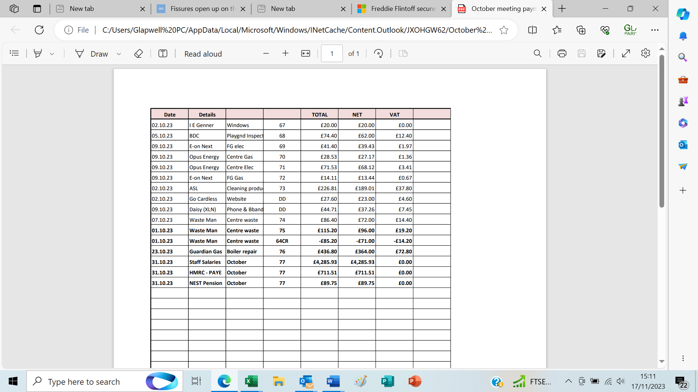

1. Income and expenditure, bank reconciliation

The Responsible Financial Officer presented the Income and Expenditure Account for September 2023 and bank reconciliation as at that date.

**RESOLVED That these are received and approved**

**10/10/23 Items to be included on the next agenda (Thursday 23rd November 2023)**

Budget

**Meeting closed at 8.24 pm**

**Chair:_________________________________________ Date:________________________**